1) 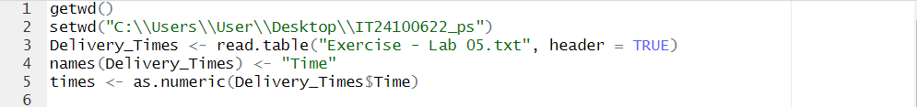

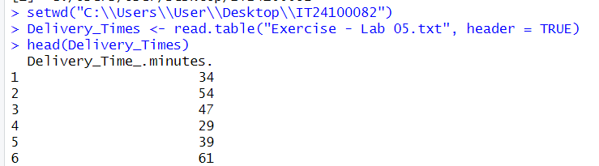

2)
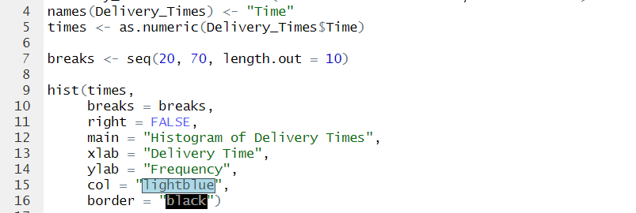
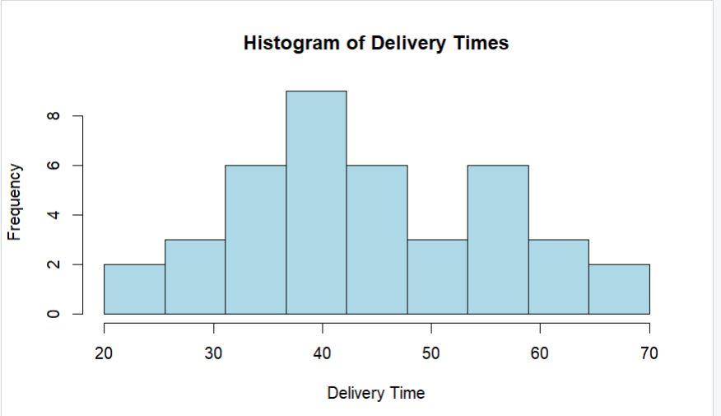
3) The distribution of delivery times is approximately symmetric, close to bell-shaped, but with a slight right skew due to a few larger delivery times

4)
